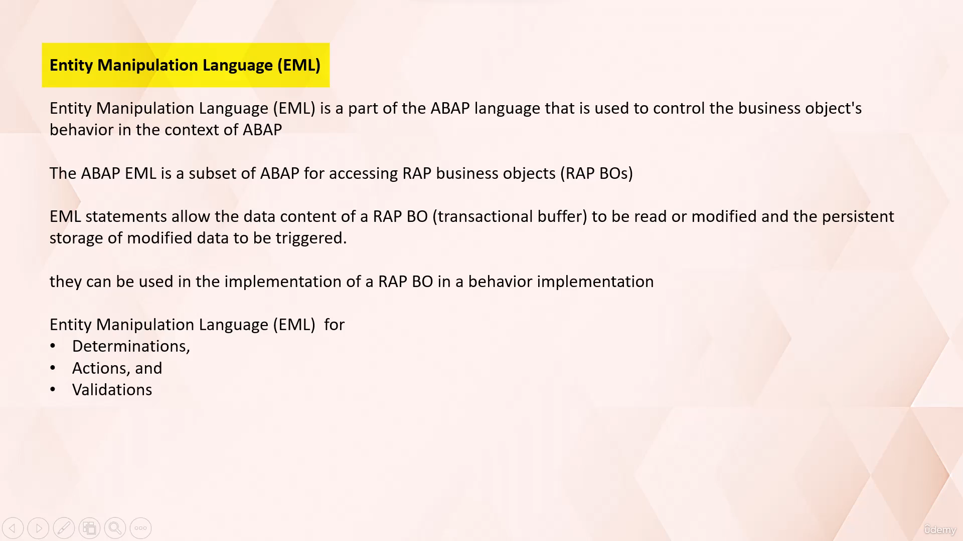In the last video lecture we have seen entity manipulation language is used for accessing business object

in RESTful application programming model, and it allows the data content of transactional buffer to

be read or modified.

In this video lecture, let's get familiar with entity manipulation language and its most commonly used

Abap statements so that we can use them in coding during the implementation of validation, determination

and action.

The entity manipulation language is a key part of Abap language that interact with the business object

using SQL like syntax.

The entity manipulation language.

In short, UML is used for handling entities which are nothing but the objects defined in the business

definition.

It offers several operations to manipulate these entities, including read, create, update, and delete.

Clean, short email provide developers with the flexibility to perform various operations on the business

object, making it essential tool for developing complex business applications.

Entity Manipulation language is a powerful tool in Abap programming that allows you to customize and

control the behavior of business objects.

One of the primary ways it does this is through determination, action, and validations.

Now let's discuss about the determination.

It.

Determination is an optional part of business object behavior that modifies instances of business objects

based on trigger conditions.

A determination is simply evoked by framework.

If a trigger conditions of determination is fulfilled, trigger conditions can be modified.

Operations and modified fields.

For example, determination can be used to set default values of the fields at the time of creation

of new instances or new records.

In the context of RESTful application programming model.

An action is a non-standard operation that is something other than the standard operations create,

update, and delete, which changes the data of business object instance.

For an example, suppose you have a travel booking order object with the attribute of booking order

status.

In this case, you could create an action that sets the order status to boot when the order is fulfilled.

The validation is an optional part of business object behavior that checks the consistency of business

object instances based on trigger conditions.

If validation is implicitly invoked by Business Object Framework, if trigger condition of validation

is fulfilled, trigger conditions can be modify operations and modified fields.

For an example, a validation can be put on travel booking date so that past it will not be accepted

for it.

Now let's look at a few above statements in entity manipulation language.

Read statement provides read access to entity instances and returns the requested instance and fields.

This statement can be used as a basic operation that provides necessary data to work with subsequent

business logic.

The read statement is introduced by the keywords read entities of, followed by the root entity name.

Here, the keywords in local mode are used to ensure privileged access to the underlying CDs views.

The affected entity name is specified after keyword entity.

This can be a root entity name or any other entity name in the composition tree under the root entity.

Using the keyword fields, you can specify the fields whose values are to be included in the result

set of read statement.

The keywords with corresponding indicates that the read operation will be performed on the instances

with the primary keys contained in the internal table keys, and at last, the internal table specified

after keyword result contains the result of read operation.

Now let's look at the modify statement and its syntax.

We modify statement is used to change the data of entity instances.

This includes standard operations such as create, update and delete and non standard operations such

as action.

The modify statement is introduced by the keywords modify entities of, followed by the root entity

name.

The keywords in local mode are used to ensure privileged access to the underlying CDs views.

The affected entity name is specified after keyword entity.

Here this name can be a root entity name or name of node entity in composition tree.

Then we need to specify the operation name, create, update or delete.

The keyword fields are followed by the names of the fields to be work upon.

After the keyword wheat, we specify the name of internal table based on which the business object instance

is to be modified.

We construct our operator value can be used to construct an internal table that indicates which instance

are to be modified with which values.

That's it for now.

In the next video tutorial we will see how to use entity manipulation language in implementation of

validation.

Thank you for watching this video.

See you in the next video lecture.

Autoscroll

Course content

Overview

Q&AQuestions and answers

Notes

Announcements

Reviews

Learning tools